


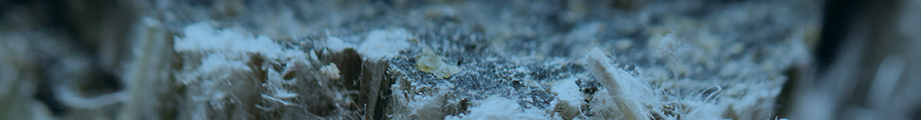
- What is mesothelioma?
Mesothelioma is a cancer of the mesothelium (surrounding tissues) of the lungs and abdomen. Pleural mesothelioma affects the pleura, which lines the lungs and chest wall. Peritoneal mesothelioma occurs in the peritoneum of the abdomen.
- What is asbestos?
Asbestos is a naturally occurring mineral that is a recognized carcinogen. Once valued as a fire and chemical resistant material, it was widely used in the construction, automotive, military, marine, and manufacturing industries. When it is cut or crushed, the microscopic fibers can be inhaled or ingested.
- Who is at risk for developing mesothelioma and other asbestos-related disease?
Workers who were exposed to asbestos for long periods of time, such as those in the construction, pipefitting, and plastering professions, have an increased risk of getting sick. In addition to this occupational exposure, workers can unknowingly expose their families to asbestos after coming home with fibers on their clothing. Many cases of asbestos disease in spouses and children have been reported, due to this take home, or indirect exposure.

- How long does it take for mesothelioma to develop?
The latency period of mesothelioma, or the time between first exposure and when the diseases presents itself, is generally between 15 and 50 years. On average, a person has asbestos exposure 40 years before developing mesothelioma.

info graphics will slide in and out with a fade effect. Similar to the meso quiz.
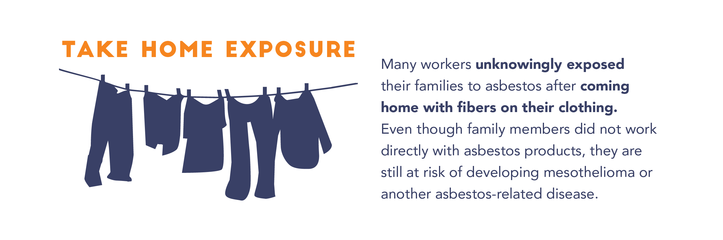
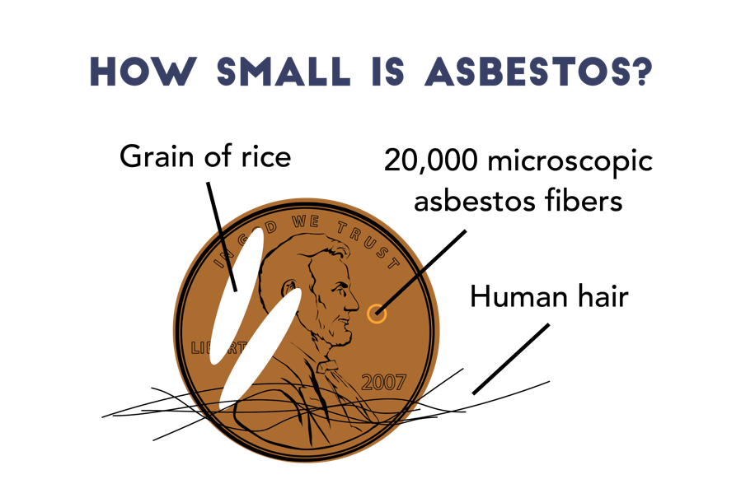
- What is mesothelioma?
Mesothelioma is a cancer of the mesothelium (surrounding tissues) of the lungs and abdomen. Pleural mesothelioma affects the pleura, which lines the lungs and chest wall. Peritoneal mesothelioma occurs in the peritoneum of the abdomen.
- What is asbestos?
Asbestos is a naturally occurring mineral that is a recognized carcinogen. Once valued as a fire and chemical resistant material, it was widely used in the construction, automotive, military, marine, and manufacturing industries. When it is cut or crushed, the microscopic fibers can be inhaled or ingested.
- Who is at risk for developing mesothelioma and other asbestos-related disease?
Workers who were exposed to asbestos for long periods of time, such as those in the construction, pipefitting, and plastering professions, have an increased risk of getting sick. In addition to this occupational exposure, workers can unknowingly expose their families to asbestos after coming home with fibers on their clothing. Many cases of asbestos disease in spouses and children have been reported, due to this take home, or indirect exposure.

- How long does it take for mesothelioma to develop?
The latency period of mesothelioma, or the time between first exposure and when the diseases presents itself, is generally between 15 and 50 years. On average, a person has asbestos exposure 40 years before developing mesothelioma.

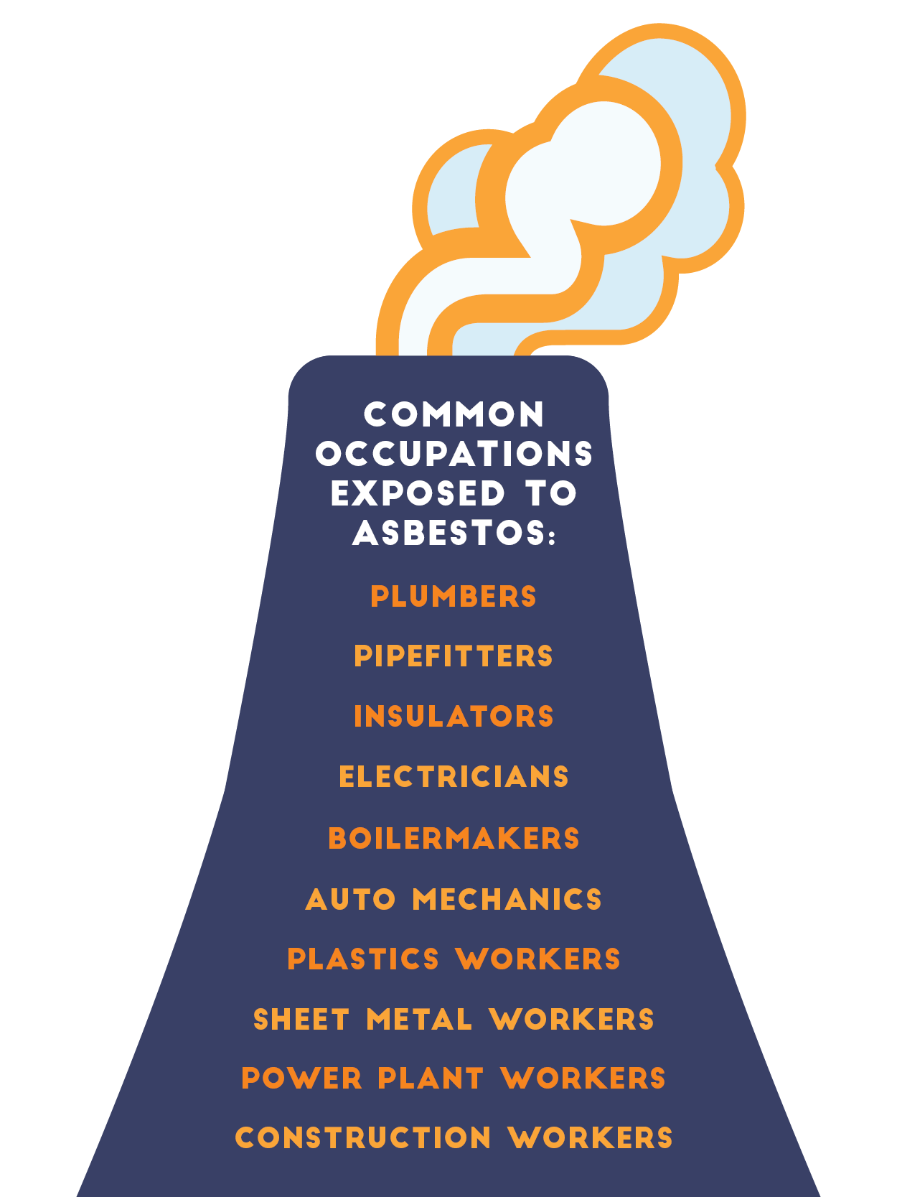
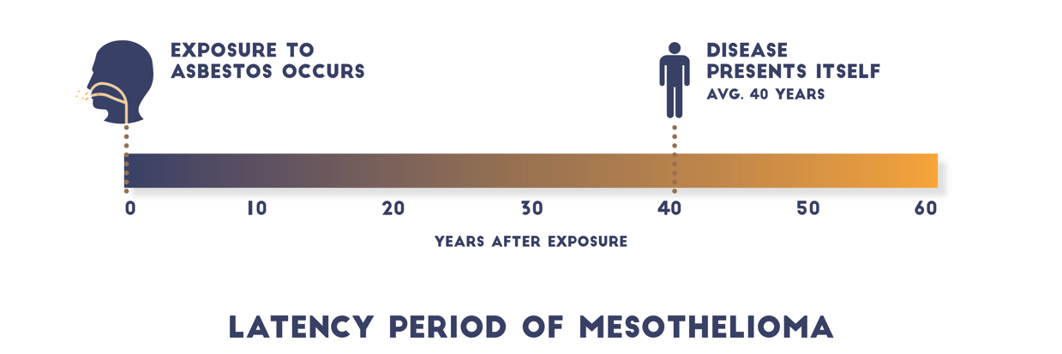
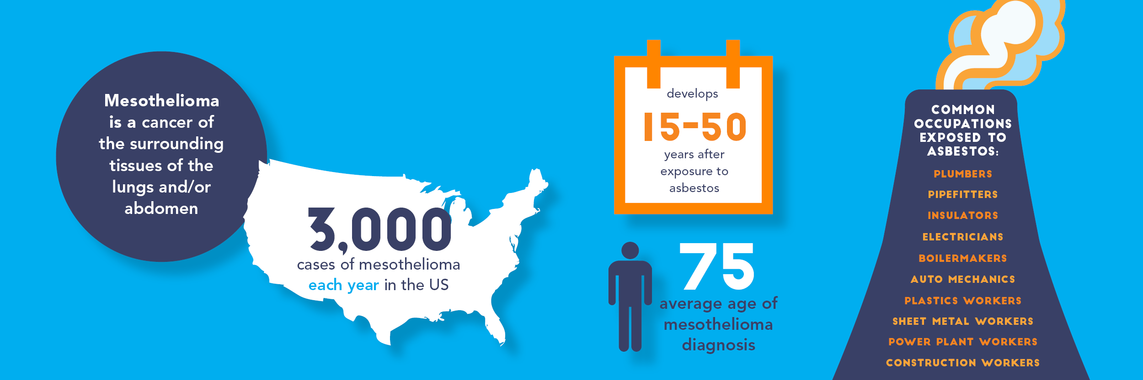
- What is mesothelioma?
Mesothelioma is a cancer of the mesothelium (surrounding tissues) of the lungs and abdomen. Pleural mesothelioma affects the pleura, which lines the lungs and chest wall. Peritoneal mesothelioma occurs in the peritoneum of the abdomen.
- What is asbestos?
Asbestos is a naturally occurring mineral that is a recognized carcinogen. Once valued as a fire and chemical resistant material, it was widely used in the construction, automotive, military, marine, and manufacturing industries. When it is cut or crushed, the microscopic fibers can be inhaled or ingested.
- Who is at risk for developing mesothelioma and other asbestos-related disease?
Workers who were exposed to asbestos for long periods of time, such as those in the construction, pipefitting, and plastering professions, have an increased risk of getting sick. In addition to this occupational exposure, workers can unknowingly expose their families to asbestos after coming home with fibers on their clothing. Many cases of asbestos disease in spouses and children have been reported, due to this take home, or indirect exposure.

- How long does it take for mesothelioma to develop?
The latency period of mesothelioma, or the time between first exposure and when the diseases presents itself, is generally between 15 and 50 years. On average, a person has asbestos exposure 40 years before developing mesothelioma.

